February 2018; 6 months after the launch of Silver Linings
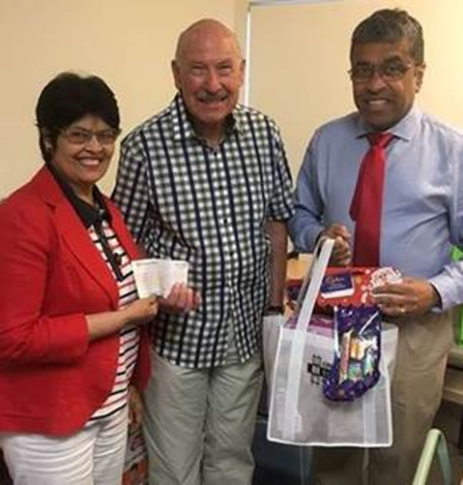
On 22nd December 2017, we took a cheque for $10,000 to Community Support Frankston, (CSF), honouring the promise made at the book launch, that the profits from book sales and donations will be given to CSF. You contributed to this $10,000 either by purchasing a book/s and or by your donations to the charity.

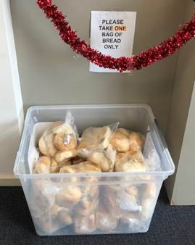
It was a humbling experience witnessing the raw need of those from our community. I would like to share with you the story of a man who arrived in search of food to feed his family. He had the choice between selecting a bag of 4 bread rolls or a loaf of bread. He chose the loaf. I politely and respectfully inquired as to why he chose the loaf of bread to which he replied, “Well, there are more serves in a loaf”. The very basics of life that I am sure many of us never think about.
I could barely hold back tears as I thanked him for his honesty and wished I had more funds to donate…

Today, I would like to humbly ask for your help in continuing this task, to assist the financially underprivileged in our community, the success of which we all share. 100% of the profits of the book sales are donated to the Silver Linings Charitable Trust. The work of the charity is pro bono and 100% of all donations is distributed to the needy.

If you already bought the book/s and enjoyed the read, please recommend them to your friends/family. If not, perhaps you too would consider a purchase of a book/s? Books for Business purposes is tax deductible.

No amount is too small if donated to the Charity and attracts a tax rebate.
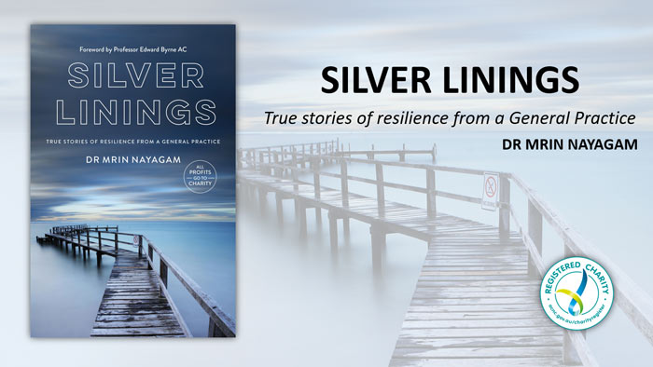
Please visit www.silverliningscharitabletrust.com.au to purchase the book or to make a donation
With Warmest wishes,
Mrin
Dr Mrin Nayagam
MBBS(Hons); MRCP(UK): FRACGP
Founding Director
Silver Linings Charitable Trust

